2021 Virtual Great Walk

Virtual Great Walk Sample Routes

Valley Route = 2.6 KM (one circuit)
Complete this route 25 times = 65 km (the distance of the Great Walk)
Complete this route 50 times = 130 km (the distance of the Great Walk x2)

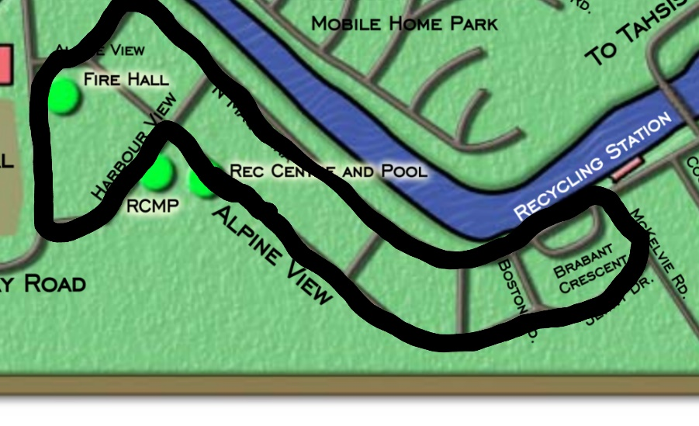

Town Route = 5.4km (one way)
Complete this route 12 times = 65km (the distance of the Great Walk)
Complete this route 24 times = 130km (the distance of the Great Walk x 2)

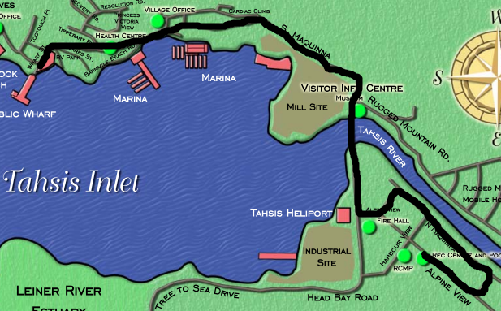
All finishers will receive a gift certificate of their choice to: Sally’s Grill, Oceanview Restaurant, Tahsis Building Supply or Tree to Sea Pottery

How to Register

There are three ways to register:

1. Contact the Tahsis Recreation Centre at (250)934-6443 or
recreation@villageoftahsis.com

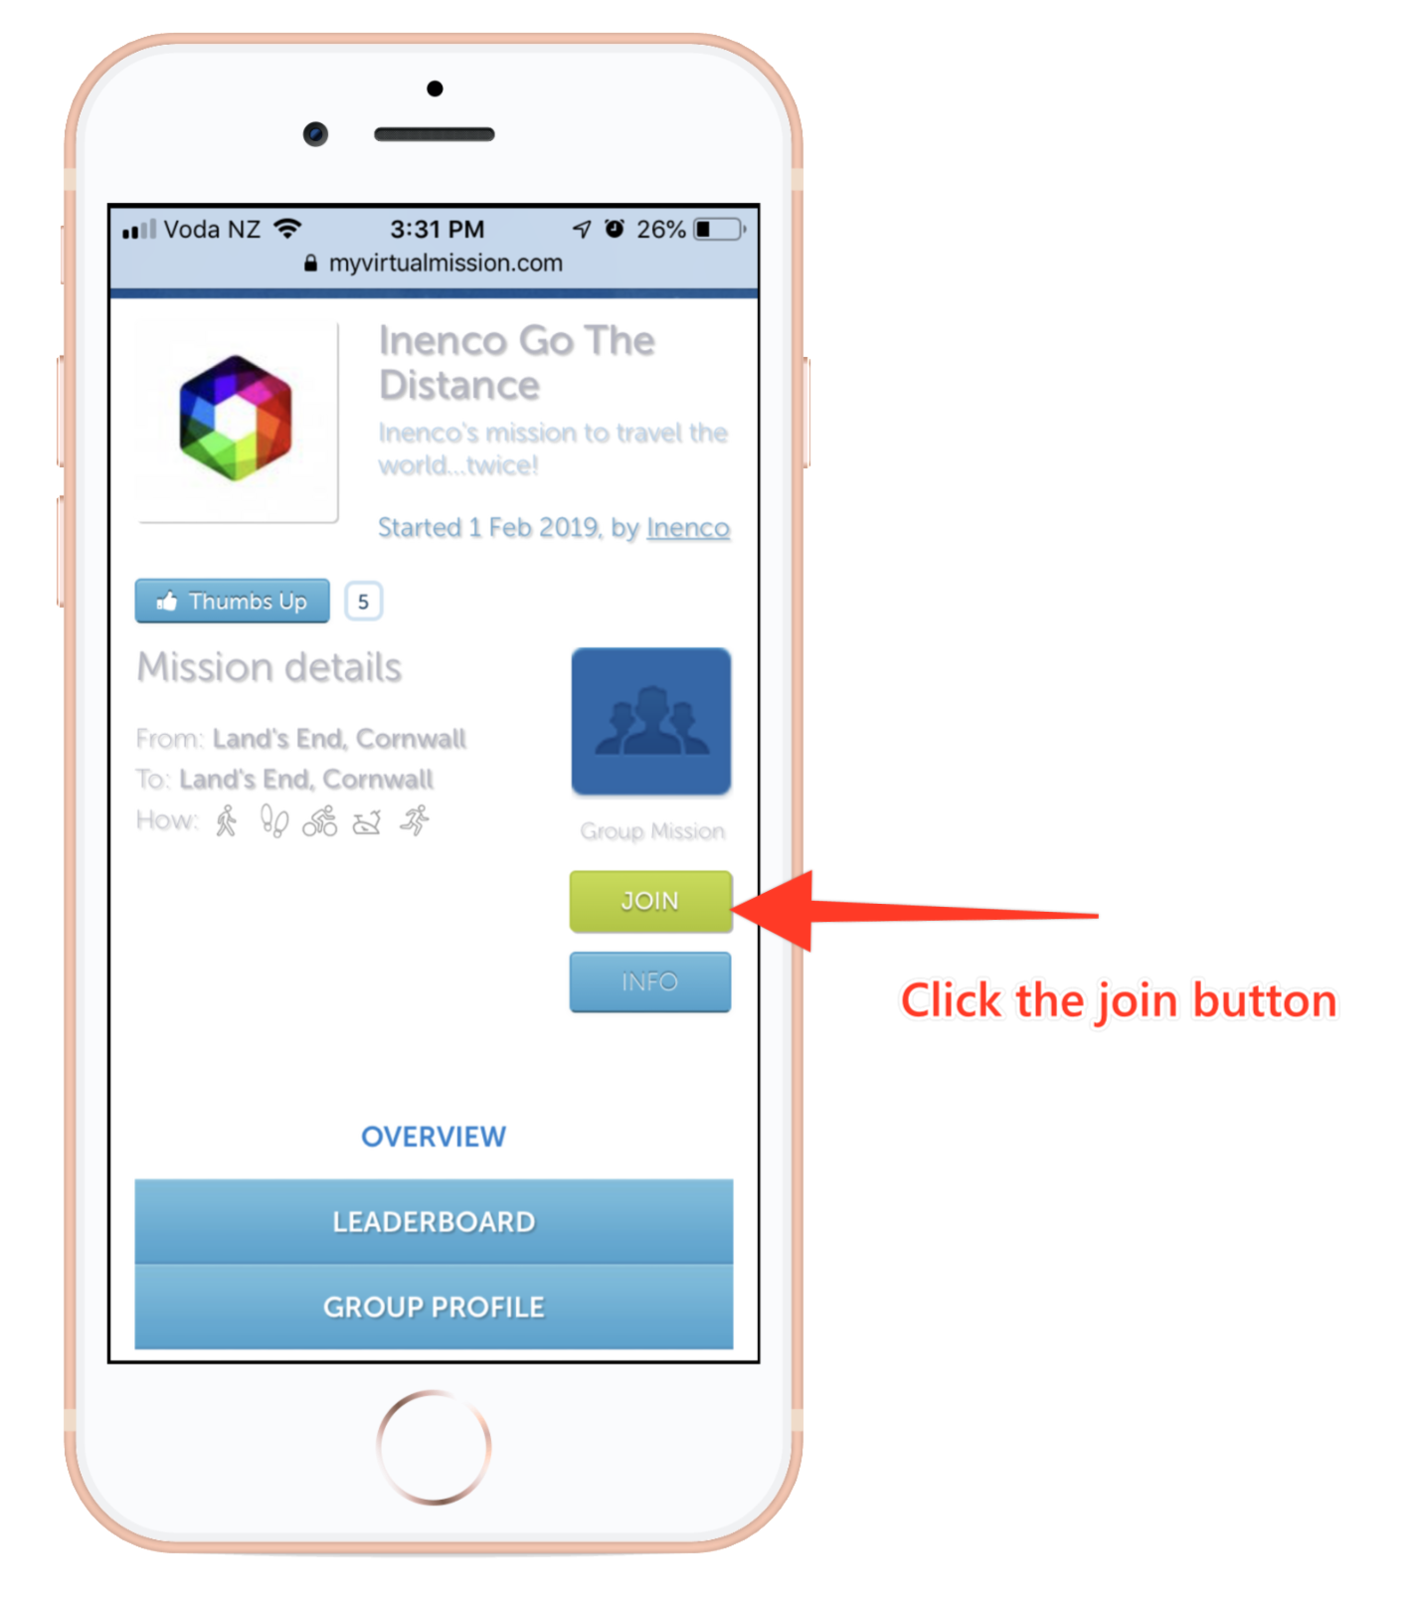
2. In the Apple App Store or in Google Play on a smartphone or tablet download the “My Virtual Mission” app.

- After downloading the app, click the “Join” button

- When prompted, type in the Mission Code “The Virtual Great Walk” and input your personal information

- Link your fitness tracker (e.g., Fitbit) with the app or manually enter your distances

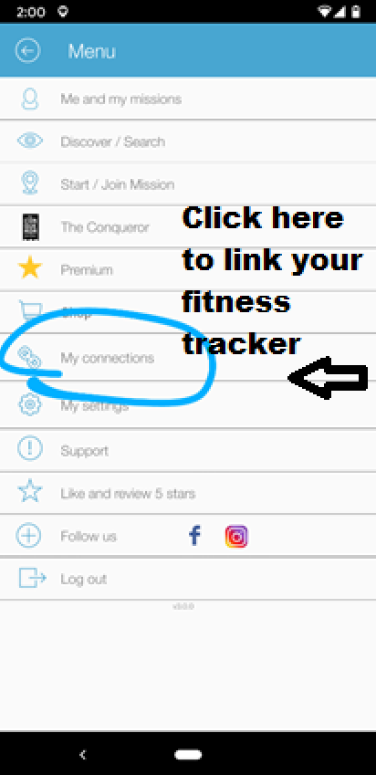

3. On a PC or laptop go to the home page www.myvirtualmission.com
- Click on the “Sign in” Button on the top right-hand side
- Click on “Sign up” on the bottom right-hand side
- Select “Pacific Time Zone”
- Select “Kilometers”
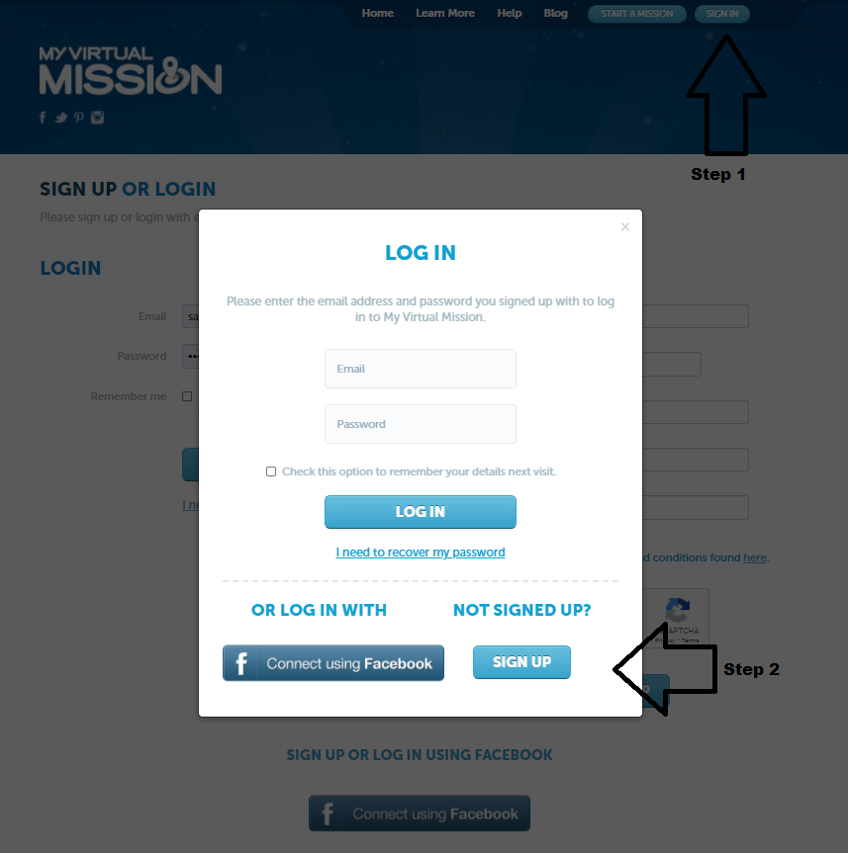

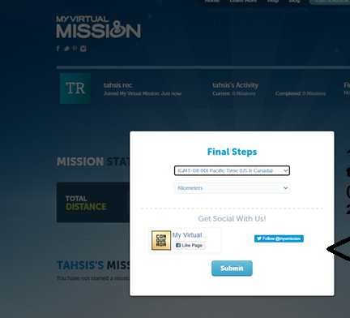

The following fitness trackers are compatible with the app:
  - Apple Health- from other apps
  - Apple Health – from daily step data
  - Strava
  - Fitbit
  - UnderArmour
  - RunKeeper
  - Google Fit – Daily Step data
  - Garmin – Activities
  - Garmin – Daily step data

Fitness trackers will automatically post the distances you cover towards your goal of completing the Great Walk or the Great Walk x2. Distances can also be recorded manually on the app, on the website or using the paper distance log (below).

Types of exercises permitted:

  - Running
  - Walking
  - Cycling
  - Elliptical

Recording distances on a PC or laptop

  - Log in on the My Virtual Mission website home page
  - Manually record distances on The Virtual Great Walk page

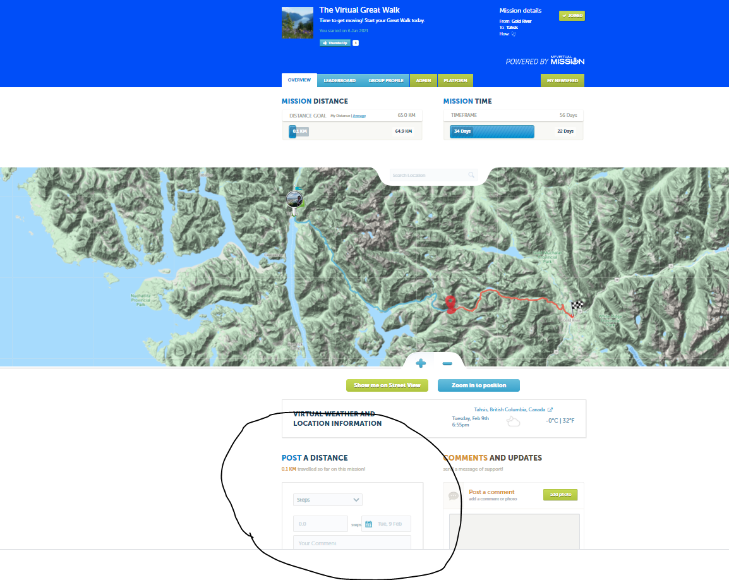

2021 Virtual Great Walk

Distance Log

Include on a separate sheet the contact information of the person who verifying your distances. Please print and copy or contact the Rec Centre for more copies.

Date | Distance completed | Type of Activity | Verifier’s signature

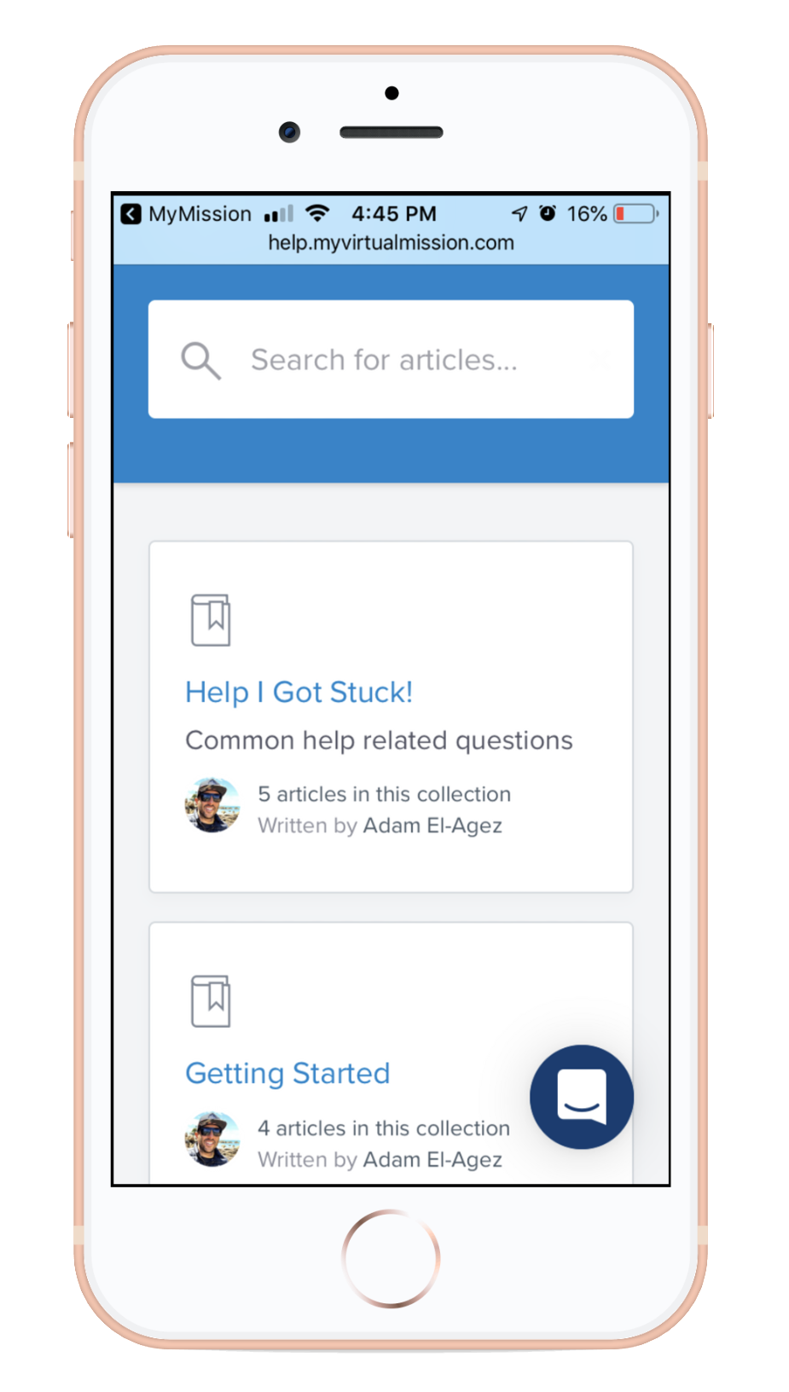
Tech Support
For support with the app go to: http://help.myvirtualmission.com

A 24/7 support team is available to assist with any technical queries at support@myvirtualmission.com

You can also access support via the My Virtual Mission App by clicking “Support” on the Main Menu.

