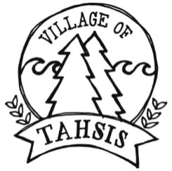

Tahsis Recreation Customer Relations Coordinator

The Village of Tahsis is seeking motivated, service-oriented individuals looking to join our team. This is a part-time on-call position.

Tasks and Responsibilities
- Assists Recreation Director with promoting and marketing programs and events.
- Greets customers, provides in-person guidance and information, ensures the lobby area is well-maintained and records statistics
- Performs standard office data entry and word processing functions, and creates documents using Microsoft Word and Excel, e.g., creating graphs and charts from statistics.
- Handles sales of services and concession items.
- Assists Recreation Director with updating facility and staff schedules
- Takes and records pool water test results.
- Provides quality customer service to facility patrons.
- Plans organize and coordinate daily assigned work such as developing community resources and upcoming programs
- Assists with set up for activities and events (as needed)
- Performs additional activities at the direction of the Recreation Director
Qualifications:

- Proficient in Microsoft Word, Excel and Outlook
- Clear written and verbal communication skills
- Experience in point of sale and cash handling
- Excellent interpersonal and communication skills
- Ability to work well independently and with others
- Ability to understand and carry out job related instructions

Compensation: $12.96/hour + 4% vacation pay

A copy of the job description is posted on the Village website www.villageoftahsis.com

Qualified applicants are invited to submit their application including cover letter and resume to reception@villageoftahsis.com

For more information on the position, please contact Sarah Jepson, Recreation Director, at (250)934-6443 or sjepson@villageoftahsis.com.

Applications will be received until June 1, 2018

