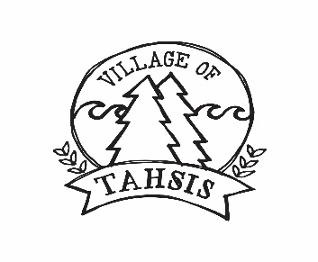

PART-TIME/FULL-TIME PUBLIC WORKS

The Village of Tahsis is currently recruiting self-motivated, hard-working, responsible team players for part-time and/or full-time positions. We are seeking mature, physically fit, safety minded individuals who enjoy the challenges of outdoor work and have experience and/or education in the following areas:
- manual labour using a variety of equipment and hand and power tools
- vegetation brushing, grass cutting
- asphalt repair and maintenance
- storm drainage, cleaning and maintenance
- other related duties
Preference will be given to candidates who have completed Grade 12 and who have experience with operating and servicing construction and maintenance equipment.
Sewer works and/or water works certification experience is an asset.
Good physical condition with sufficient strength and stamina to perform heavy manual work outside in the presence of all types of weather conditions is a requirement.
A valid Class 5 Driver Licence is required. A driver’s abstract may be required.
The wage rate range is from $13.00 to $19.63 depending on experience and/or education (certifications). Benefits may be available to full-time employees.
Applicants are asked to submit a cover letter and resume to reception@villageoftahsis.com. Applications will be reviewed on an ongoing basis as positions become available.

